STUDENTLIFEKIDSCAMP.COM • 1 LIFEWAY PLAZA, NASHVILLE, TN 37234 • TEL: (888) 213-6038

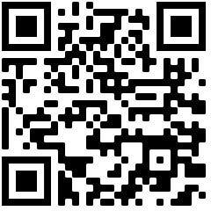
Camp Participant Forms Required Information

Camp Participant Form Link: https://studentlifekidscamp.com/parents/

REG ID (optional):

Camp Location & Date:

Church Name & Address:

Group Leader Name & Email Address:

